Name: Pretor
5
Class: Warlock (Great Old One)
Show extra features
Player: Jack Hollingsworth

Experience: 6.500 Add:
Next level: 14.000

LEVEL
Background: Criminal
Race: Human (Variant) Size:
Medium Height: 5' 11"
Weight: 180

Gender: M Hair: Dark
Eyes: Hazel
Skin: Sallow

Abilities
Age: 25
Alignment: Neutral Evil
Faith: Heretic [Karamaka]

Skills
ADV
DIS BONUS NAME (ABILITY) PROF. EXP.

ABILITY MODIFIER SAVING THROW

PROF. BONUS

Ability save DC +3
Acrobatics (DEX)
Animal Handling (WIS)
+6
+1
= 8 + +
14

13 STR
STRENGTH
+1 +1
PROFIENCY BONUS

Charisma
+5 Arcana (INT)
+1 Athletics (STR)

16 DEX
DEXTERITY

CON

+3 +3
Senses
Passive Perception
11

Proficiency Bonus
+6 Deception (CHA)
+5 History (INT)
Insight (WIS)
+1

12
CONSTITUTION

14 INT

INTELLIGENCE

12 WIS
WISDOM

16 CHA
CHARISMA

+1 +1

+2 +2

+1 +4

+3 +6
Devil's Sight 120 ft
INSPIRATION
Limited Features SR LR Dawn
FEATURE MAX. USAGES RECOVERY USAGES

3rd level Spell Slots 2 SR
Intimidation (CHA)
+2 Investigation (INT) Medicine (WIS) Nature (INT) Perception (WIS) Performance (CHA) Persuasion (CHA) Religion (INT)
+3
+1
+2
+1
+3
+3
+2
+3
+6

Sleight of Hand (DEX)

Saving Throw Advantages / Disadvantages
Stealth (DEX)
Survival (WIS)
+1
Thieves' Tools (DEX)
+6

SPEED
30 ft

Combat Defense

ARMOR BONUS
14
+

AC DURING REST
+3

Health

Heal
DEX MISC.
Initiative +
3
SPEED
ENCUMBERED

20 ft

WOUNDS

19 2

SHIELD
Breastplate
14
Shield
BONUS
HALF DAMAGE

CURRENT
TEMPORARY HP

+
AC 2
+

+
1
DEXTERITY
MOD MAGIC
Thorn's Training
MEDIUM ARMOR (MAX = 2)
HEAVY ARMOR (MOD = 0)
STEALTH
DISADV.
RESISTANCE
HP 43
MAX HIT POINTS

5 D 8 + 1
I DC10

MISC MOD 1
D + II

Attacks
+
MISC MOD 2
ATTACKS PER ACTION
RECOVER HALF OF YOUR MAXIMUM
HIT DICE AFTER A LONG REST.

Actions
HIT DICE
D +
LEVEL DIE CON

USED
III

WEAPON / DESCRIPTION

PROF ABILITY

RANGE

TO HIT DAMAGE DAMAGE TYPE
1

MAXIMUM OF 1 ACTION, 1 BONUS ACTION, AND 1 REACTION PER TURN.

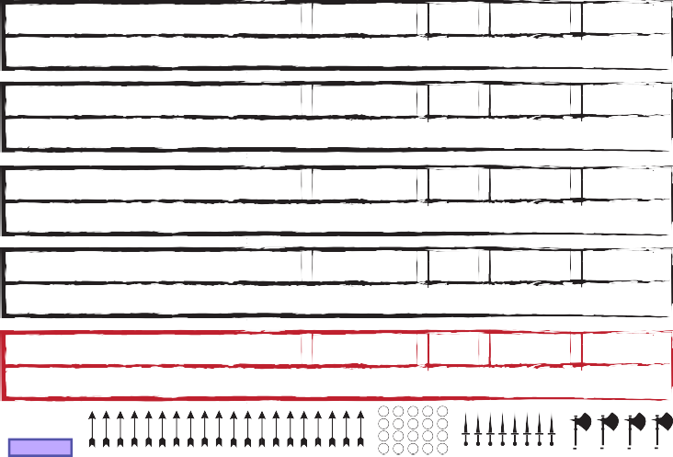
Eldritch Blast ✔ Cha 120 ft. +6 2×1d10 Force

Each d10 is a separate beam requiring separate rolls (PHB 237)
Spear ✔
Str | Melee, 20/60 ft. | +4 | 1d6+1 | Piercing
Dex | 80/320 ft. | +6 | 1d8+3 | Piercing

Thrown, versatile (1d8)
Light crossbow ✔
Ammunition, loading, two-handed
Dagger ✔ Dex Melee, 20/60 ft. +6 1d4+3 Piercing

Finesse, light, thrown
Mace +1 ✔ Str Melee +5 1d6+2 Bludgeoning

The Keller-Manzarek
Attack / Cast a Spell Dash / Disengage / Dodge
Escape Grapple / Help / Hide
Ready / Search / Use Object

Overrun / Tumble (or as bonus action)
As 1 attack: Disarm / Grapple / Shove
BONUS ACTIONS REACTIONS
Spell: Hex Opportunity Attack Spell: Hellish Rebuke

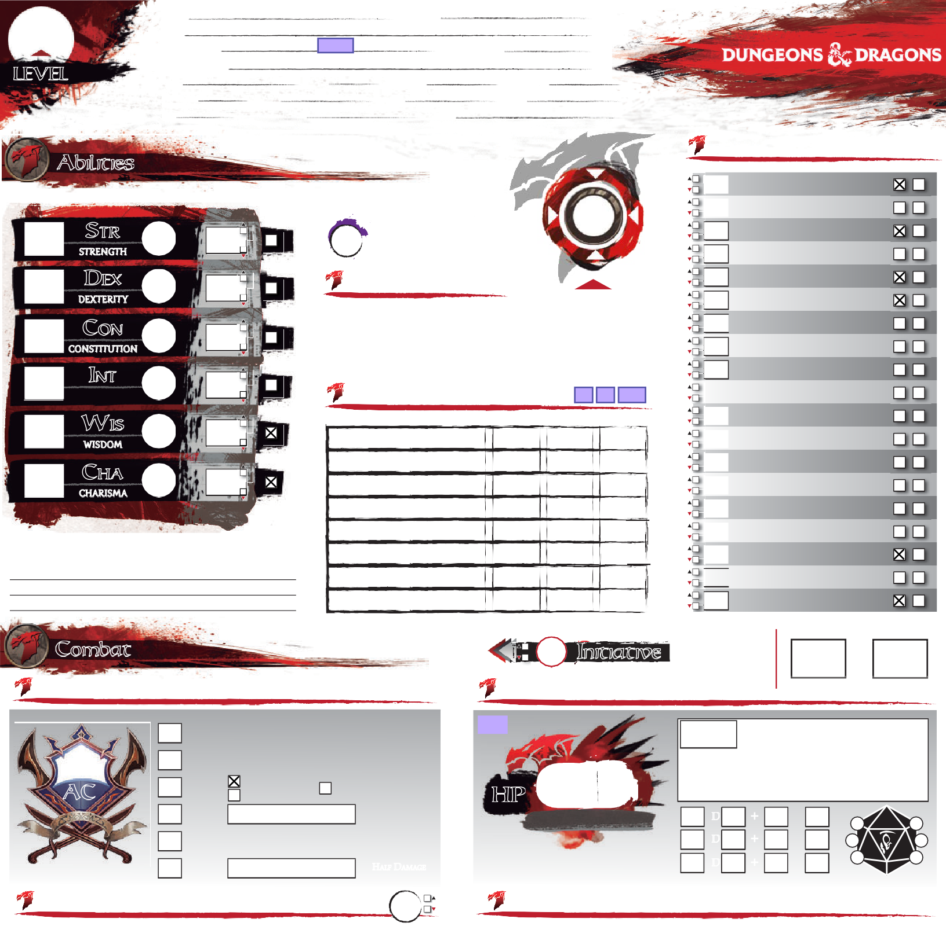
AMMUNITION
Reset Ammo

Features Racial Traits

Get the latest version of this sheet on enworld.org

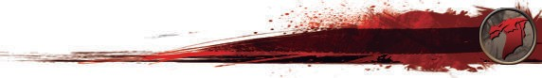 Check out the good stuff, Hired Killer
Background
PERSONALITY TRAITS
Add Features

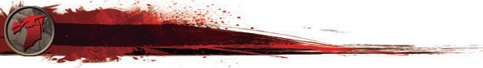 Human (+1 to two different ability scores of my choice)
Skills:
I gain proficiency in one skill of my choice.

Feat:
I gain one feat of my choice.
Class Features
Armor: Light MMedium Heavy Shi
Weapons: Si Ma tial Other:
Choose Feature

Thorn's Training -"My Armor is a Second Skin" +1 to Dex add Maximum and no
L
Shields
Simple
Mar
O
disadvantage to stealth rolls while wearing chain

Warlock (Great Old One), level 5: 2 Spell Slots, 3rd Level power
- Pact Magic (Warlock 1, PHB 107)
I can cast warlock cantrips/spells that I know, using Charisma as my spellcasting ability
I can use an arcane focus as a spellcasting focus
I regain these spell slots on a short rest
- Awakened Mind (Great Old One 1, PHB 110)
I can communicate telepathically one-way to any seen creatures within 30 ft of me
- Eldritch Invocations (Warlock 2, PHB 107) [3 invocations known]

IDEAL
Aspiration: do what it takes to be wealthy

BOND
with an actual Great Old one-pay off a debt by creating a new religion

FLAW
Forget the plan!!!
FEAT:
Moderately Armored
Feats
Bonus feat from being a human; (PHB, page 168)
I gain proficiency with medium armor and shields.[+1 Strength or Dexterity]

FEAT:

Use the "Choose Features" button above to add Eldritch Invocations to the third page
- Pact of the Tome (Warlock 3, PHB 107)

I have a Book of Shadows with any three cantrips of my choosing
FEAT:
I can cast these cantrips as long as I have the book on my person
Regardless of the lists they come from, these count as warlock cantrips to me
I can get a replacement book with a 1-hour ceremony during a short or long rest
Equipment
Add Equipment
FEAT:

A G |  | W
Case w/20 bolts 2.5#
Burglar's Pack 186#
Herbalist's Kit 3#
Light Crossbow 5#
Scroll Case 1#
5 sheets Paper
Pouch 1#
Blanket 3#
Candles | 5
Pen | 2
Sack 1/2# | 2
Longbow 2#
Quiver w/12 Arrows 1.6#
Club 2#
Dice gaming set
Torch 1# | 6
Noble Finery 6#
Robes 4#
Travelers Clothes 4#

I have a reliable and trustworthy contact who acts as my liaison to a network of other
Background Feature
Criminal Contact
criminals. I know how to get messages to and from my contact, even over great distances;
specifically, I know the local messengers, corrupt caravan masters, and seedy sailors who
can deliver my messages.

Keller Manzarek |  | 4
 |  | 4
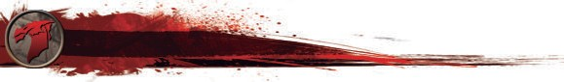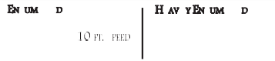H AG LI T TOTAL WEIGHT
Proficiencies
Languages
Tools & Others
66 -
HEA IL E E E
STR × 5
131 -
STR × 10
130 lb.-
195 lb.
-
20 FT. SPEED
DISADV. STR, DEX, CON
PLATINUM GOLD ELECTRUM SILV
= 10 GP =10SP = 5 SP =10
A
I
A G |  | W
Explorer's Pack |  | 16
Focus (Crystal) |  | 1
Healer's Kit (10) |  | 3
Tankard |  | 1
Thieves Picks and Tools |  | 1
Pouch |  | 1
Whistle |  | 0
Chalk | 2 | 0
Healing Potion (level 2) |  | 0.5
Shield |  | 6
Spear |  | 3
Dagger and Sheath |  | 1
Breastplate |  | 20
Common Clothes |  | 3
 |  | 56.5

196 -
61.1 lb.
STR × 15 - 30

390 lb.SPEED = 5 FT.
ER COPPER LIFESTYLE:
30 DAILY PRICE:
GEMS AND OTHER VALUABLES:
2-10 gpv

CP

GEAR & COINS

Common
Undercommon

Dice gaming set
Thieves' tools

©DESIGN BY JAVIER AUMENTE - JAAUVEL@GMAIL.COM; EDITS & FORM FIELDS BY JOOST WIJNEN - FLAPKAN@GMAIL.COM. THE D&D LOGO AND DRAGONS ARE ©WIZARDS OF THE COAST

CHARACTER: Pretor
MAGIC ITEM: Circlet of Disguise
ATTUNED

oss ssions
Status

Exhaustion
Magic Items

functions as a Hat of Disguise
MAGIC ITEM: Keller Manzarek
✔ ATTUNED
Mace +1, acts as a Spell Focus, Heals up to 3x level in HP (Long Rest to recharge)

MAGIC ITEM:
ATTUNED
FINISHING A LONG REST REDUCES THE EXHAUSTION LEVEL BY 1,
PROVIDED THAT YOU ALSO INGESTED
SOME FOOD AND DRINK.

Blinded
Conditions
LEVEL EFFECT (CUMULATIVE)
- Disadvantage on Ability Checks
- Speed halved
- Disadvantage on Attack Rolls and Saving Throws
- Hit Point maximum halved
- Speed reduced to 0
- Death
Fail checks involving sight; attacks have disadvantage; enemy attacks have advantage.

Charmed
Cannot harm the charmer; charmer has advantage on any social interaction.

Deafened
Fail checks involving hearing.

Frightened
Check and attacks have disadvantage when source of fear is in sight; cannot willingly move closer to the source of fear.

Grappled
Petrified
Become incapacitated; become paralyzed; gain resistance to all damage; stop aging; immune to poison or disease; weight increase by a
MAGIC ITEM:
ATTUNED
©DESIGN BY JAVIER AUMENTE - JAAUVEL@GMAIL.COM; EDITS & FORM FIELDS BY JOOST WIJNEN - FLAPKAN@GMAIL.COM. THE D&D LOGO AND DRAGONS ARE ©WIZARDS OF THE COAST
factor of 10.

Poisoned
Ability checks have disadvantage; attacks have
disadvantage.
MAGIC ITEM:
ATTUNED

Prone
Only move by crawling or stand up; attacks
have disadvantage; enemy attacks have
advantage if within 5 ft or have disadvantage
otherwise.

Restrained

Speed drops to 0.
Speed drops to 0; attacks have disadvantage; enemy attacks have advantage; Dex saving
MAGIC ITEM: ATTUNED

Incapacitated
Cannot take actions or reactions.

Invisible
Cannot be seen (normally); attacks have advantage; enemy attacks have disadvantage.

Paralyzed
Become incapacitated; fail Str and Dex saving throws; enemy attacks have advantage; enemy attacks within 5 ft are critical hits; cannot speak, move or take physical actions.
throws have disadvantage.

Stunned
Become incapacitated; fail Str and Dex saving
throws; enemy attacks have advantage; cannot move; can only speak falteringly.
MAGIC ITEM:
ATTUNED

Unconscious
Become incapacitated; fall prone and drop
what is holding; fail Str and Dex saving
throws; enemy attacks have advantage; enemy
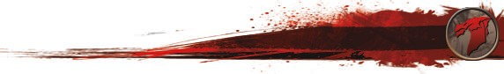attacks within 5 ft are a critical hits.
CNoomtebsat Rules
◆DRaesphelling Blast (EldritAchctiIonnvocatioYnou, PgaHiBn y1o1u1r )Speed as extra movement this turn.
DiIsceannghaagvee creatures hAicttiboyn my EYlodurritcmhoBvelamsetnctadnotreispn’tbeprpouvsohkeed O1p0poftrtauwniatyy Afrtotamckms feor the
- Devil's Sight (Eldritch Invocation,rePsHt oBf 1th1e0t)urn.
- Book of Ancient Secrets (EldritchSTInRv(oAcathtlieotnic,sP)HoBr D1E1X0()Acrobatics) check vs. opponent’s STR
DoIdcagnesee in magical aAncdtionnonmagDiicsaalddvaanrktangeessonouAttttaock12Ro0llfstagainst you. You have Advantage
on DEX Saving Throws.
EsIccaapneadGdraanpypltewo 1sAtc-tlieovnel spel(lsAtthhlaettichsa)vcehetchketroitbueaflrteaegoftothemgyraBpopolkedocfoSnhdaitdioonw.s
HeIflpI come across spellsAwctiitohn the rYitouualgitvaega,nIaclalynAtrdavnansctraigbeeotnhethme ninetxot AmbyilibtyooCkh,eacks woreAllttack
I can cast any of these spells in mRoyllBitomokakoefsSvhs.aadnowopspaosnernittuwalist,hibnu5tfnt ootf aysoun.ormal spells
HiIdcean cast my knownAwctaiorlnock spDelElsXa(sStreiatultahl)scihfetchkevys.hoapvpeotnheentr’istWuaIlSt(aPgerception) check.
Win opposing STR (Athletics) check to move through opponent’s
Spells:
Overrun
Action or Bonus Action
space once this turn. Advantage if you are larger than opponent and disadvantage if you are smaller than opponent.
CRaenatdriyps: Eldritch BlastAction
Mage Hand
TSheoarrncWh hip (Book)
Action
You choose an action you will take in response to a trigger, using your Reaction. Readying a spell requires concentration.
You search for something.
TThuamumbaleturgy (Book)B Action or n Win opposingc DEX e(Acrobatics) check to move through
Shocking Grasp (Book)
onus Actio opponent’s spa e onc this turn.
CUhsilel TOobucjhect
Action
You interact with an object.
You can interact with an object once per turn for free.
Weapon attack roll vs. opponent’s STR (Athletics) or DEX (Acrobatics) check to knock one item from its grasp. You have
Arms of Hadar hands. Opponents larger than you have advantage. Opponents
1Dsits:aHremx
Attack disadvantage if opponent is holding item with two or more
Dissonant Whispers HGerllaisphpRleebuke
smaller than you have disadvantage.
Win STR (Athletics) check vs. opponent’s STR (Athletics) or DEX
Attack (Acrobatics) check. Can only start grapple with opponents that
are up to one size larger than yourself.
2nd: Detect Thoughts 3Mrda:rMkagic Circle
Together with a melee attack you can mark the target of that Melee attack. Until the end of your next turn, make one opportunity Attack attack against the marked target with advantage without
expanding your reaction.
RSihtuoavlse(Book)
Find Familiar w1
Attack

TMenosvere'sGFrloaaptipnlgeDdisk wM1ove
Win opposing STR (Athletics) check to move opponent 5 ft back. Disadvantage if trying to move the opponent to a side.
Bring grappled opponent along with you as part of your move action, but can only move half speed unless opponent is two or more sizes smaller than you.
Choose Visible Sections

Combat Rules

G
W G W
EDxpalsohrer's Pack ConteAncttsion You gain yo uBr uSpregeladra'ss ePxatrcakmCoovenmteennttsthis turn.

Backpack
Your
acks
mo5ve mBenatckdpoeascnk’t provoke Opportunity Att for5the

1D0i'sSetnrginagge Action
est
e Ad
r of the t uBrna.g of 1000 Ball Bearings 2

MDeossdgKeit Tinderbox
Action
Disadvan1tage on Attack Rolls against you. You hav on DEX Saving Throws.
STR (Ath1letics) or DEX (Acrobatics) check vs. opp
A3thl
Bell
vantage
nt’s STR
one
on5.

TEosrccahpese Grapple Action
( etic1s) chCeacnk dtolebse free of the grappled conditi

DHaeillypRations
Roll
Action
Yo3u give2an aCllryoAwdbvaanrtage on the next Ability Che it makesHvsa.manmoeprponent within 5 ft of you.
r Att5ack
3
DEX
n)10ch

Hide Action
ck o
Hooded Lantern
(StealthP) icthoencksvs. opponent’s WIS (Perceptio
e0c.k2.5

Overrun
Action or Bonus Action
Win opposing STR (Athletics) check to move through oppone2nt’s space once this turn. Advantage if you are larger than opponent and disadvantage if you are smaller than opponent. 2 1

Ready Action
your
Flask Oil
You choose aDn aaciltyionRyaotuiownisll take in response to a tri1g2ger, 1us0ing

Search Action
Action or onus Actio
Tumble B n
Use Object Action
ReactioTn.inRdeaedrybionxg a spell requires concentra You search foWr asotmerestkhiinng.(full)
Win opposing DEX (Acrobatics) check to mo
50' Rope (hemp)
opponent’s space once this turn. You interact with an object.
Bedroll
You can interact with an object once per turn for fr
Weapon attack roll vs. opponent’s STR (Athleti
1
8
2
thr1o0ugh
ve2
7
ee.

or DEX
cs)

Disarm Attack
tion.
(Acrobatics) check to knock one item from its grasp. You have disadvantage if opponent is holding item with two or more hands. Opponents larger than you have advantage. Opponents

s ler than you have disadvantage.
TOTAL WEIWGHinT STR16(Athletics) check vs. opponent’s STTORTA(LAWthEleIGtHicTs) o1r8D6EX
mal

Grapple Attack
(Acrobatics) check. Can only start grapple with opponents that are up to one size larger than yourself.

Other HMoellede ingTosgether with a melee attack you can mark the target of that

Mark

Attack
attack. Until the end of your next turn, make one opportunity attack against the marked target with advantage without

expanding your reaction.

Shove Attack

Move Grappled Move
Win opposing STR (Athletics) check to move opponent 5 ft back. Disadvantage if trying to move the opponent to a side.
Bring grappled opponent along with you as part of your move action, but can only move half speed unless opponent is two or

©DESIGN BY JAVIER AUMENTE - JAAUVEL@GMAIL.COM; EDITS & FORM FIELDS BYmJOoOrSTeWsiIJzNeENs- sFLmAPKaAlNl@eGrMtAhILa.CnOMy. ToHuE .D&D LOGO AND DRAGONS ARE ©WIZARDS OF THE COAST

Appearance
Reset Portrait

Organization Symbol
Enemies
Background

Character History
Accused of Heresy

Character Portrait

Allies & Organizations

Nesserian Chord
Reset Symbol

Name: Ji'aa
Familiar
Race: Raven

Gender: Female

Age: 4

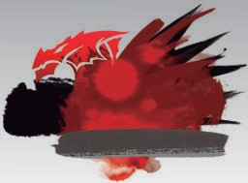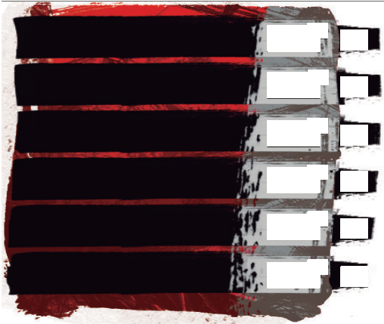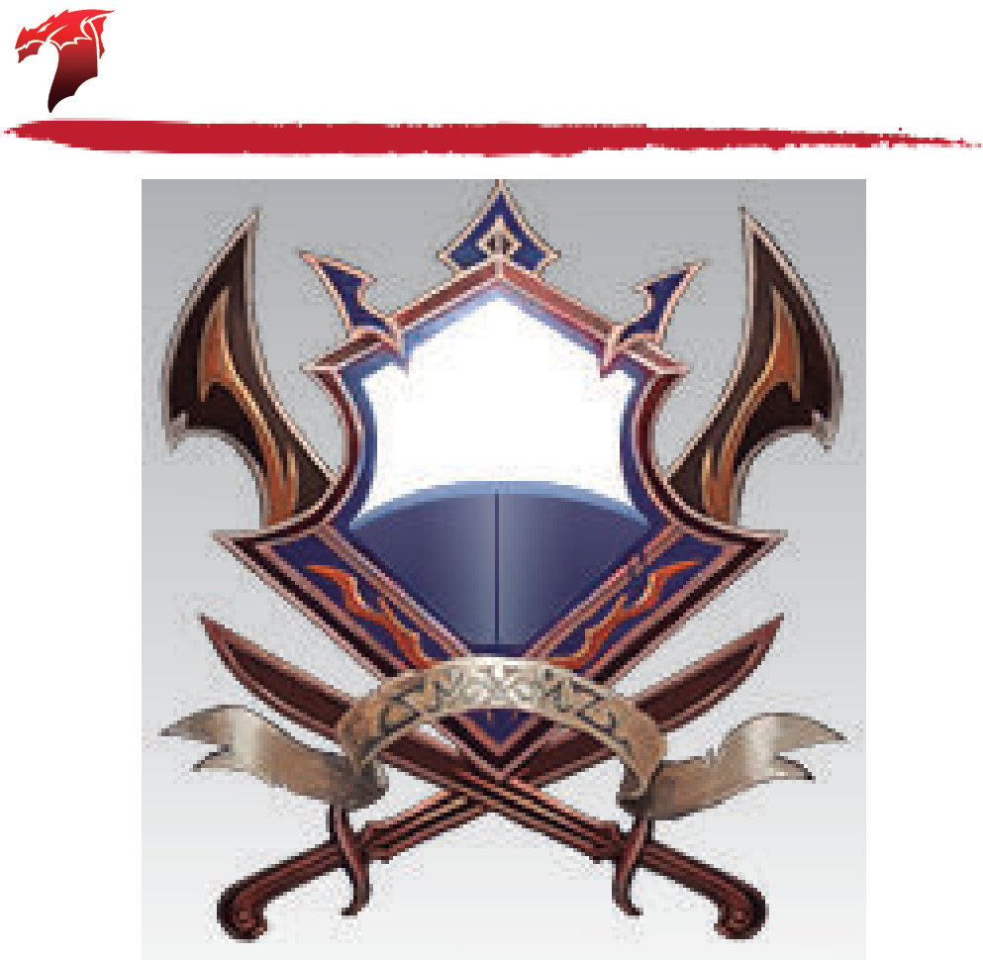Height: 8"
ABILITY
MODIFIER
10
10
STR
STRENGTH

DEX
DEXTERITY

CON
CONSTITUTION

INT
INTELLIGENCE

WIS
WISDOM
0
SAVING THROW
BONUS
0
Skills
Passive Perception
SENSES / SKILL PROFICIENCIES

Attacks
ATTACK / DESCRIPTION
ATTACKS PER ACTION
RANGE
TO HIT
DAMAGE
DAMAGE TYPE
10
0
0
0
0

Speed
10
0
0
Health
10
0
0
Defense
I DC10
10
CHA
CHARISMA
0
0
II
TEMP.
III
AC
HP
MISC.
DEX
MAX HIT POINTS
HIT DICE
D
+
+
Initiative
0
LEVEL
DIE
CON
USED
Features
Annotations
Heal
WOUNDS
0

Weight: 2#
Size: Tiny

Can deliver touch spells
Notes
Hide lines left column
Hide lines right column

©DESIGN BY JAVIER AUMENTE - JAAUVEL@GMAIL.COM; EDITS & FORM FIELDS BY JOOST WIJNEN - FLAPKAN@GMAIL.COM. THE D&D LOGO AND DRAGONS ARE ©WIZARDS OF THE COAST

Notes
Hide lines left column
Hide lines right column

