Name: Pretor
7
Class: Warlock (Great Old One)
Player: Jack Hollingsworth

Experience: 23.211
Next level: 34.000

LEVEL
Background: Criminal
Race: Human (Variant) Size:
Medium Height: 5' 11" Weight: 180

Gender: M Hair: Dark
Eyes: Hazel
Skin: Sallow

Age: 25 Alignment: Neutral Evil

Abilities
Faith: Heretic [Karamaka]

Skills
ADV
DIS BONUS NAME (ABILITY) PROF. EXP.

ABILITY MODIFIER SAVING THROW

PROF. BONUS

Ability save DC +3
+6 Acrobatics (DEX)
+1 Animal Handling (WIS)
= 8 + +
14

13 S_{TR}
STRENGTH
+1 +1
PROFIENCY BONUS
Charisma
+5 Arcana (INT)
+1 Athletics (STR)

16 D_{EX}
DEXTERITY

C_{ON}
+3 +3
Senses
Passive Perception
11

Proficiency Bonus
+6 Deception (CHA)
+5 History (INT)
+1 Insight (WIS)

12
CONSTITUTION

14 I_{NT}
INTELLIGENCE

12 W_{IS}
WISDOM

16 C_{HA}
CHARISMA
+1 +1

+2 +2

+1 +4

+3 +6
Devil's Sight 120 ft
INSPIRATION

Limited Features
FEATURE MAX. USAGES RECOVERY USAGES

4th level Spell Slots 2 SR
Entropic Ward 1 SR
+3 Intimidation (CHA)
+2 Investigation (INT)
+1 Medicine (WIS)
+2 Nature (INT)
+1 Perception (WIS)
+3 Performance (CHA)
+3 Persuasion (CHA)
+2 Religion (INT)
+3 Sleight of Hand (DEX)

Saving Throw Advantages / Disadvantages
+6 Stealth (DEX)
+1 Survival (WIS)

Thieves' Tools (DEX)

SPEED
30 ft

Combat Defense
Breastplate+1

ARMOR BONUS
Shield
15

AC DURING REST
15
+3

Health
DEX MISC.

Initiative +
3
SPEED
ENCUMBERED

20 ft

WOUNDS

+
20
2
+
AC 2
+
SHIELD BONUS
DEXTERITY MOD
MEDIUM ARMOR (MAX = 2)
HEAVY ARMOR (MOD = 0)
STEALTH
DISADV.
RESISTANCE
HP 60
CURRENT
TEMPORARY HP

MAGIC

+
1
MAX HIT POINTS

7 D 8 + 1
I DC10

MISC MOD 1
D + II

Attacks
HALF DAMAGE

+
MISC MOD 2
ATTACKS PER ACTION
RECOVER HALF OF YOUR MAXIMUM
HIT DICE AFTER A LONG REST.
Thorn's Training

Actions
HIT DICE
D +
LEVEL DIE CON

USED
III

WEAPON / DESCRIPTION

PROF ABILITY

RANGE

TO HIT DAMAGE DAMAGE TYPE
1

MAXIMUM OF 1 ACTION, 1 BONUS ACTION, AND 1 REACTION PER TURN.

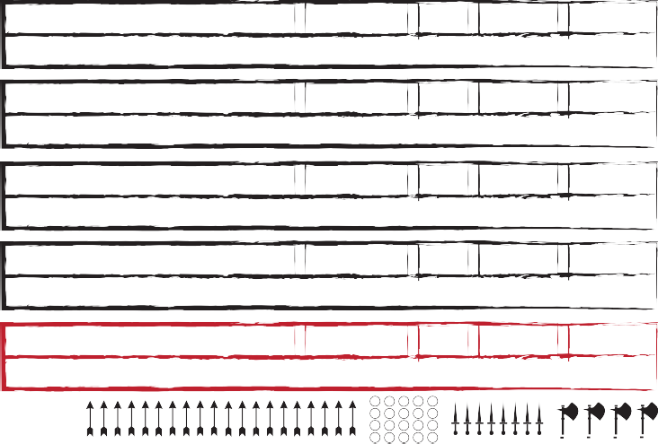
Agonizing Blast ✔ Cha 120 ft. +6 2×1d10+3 Force

Each d10 is a separate beam requiring separate rolls (PHB 237)
Spear ✔ Str Melee, 20/60 ft. +4 1d6+1 Piercing

Thrown, versatile (1d8)
Light crossbow ✔ Dex 80/320 ft. +6 1d8+3 Piercing

Ammunition, loading, two-handed
Dagger ✔ Dex Melee, 20/60 ft. +6 1d4+3 Piercing

Finesse, light, thrown
Mace +1 ✔ Str Melee +5 1d6+2 Bludgeoning

The Keller-Manzarek
Attack / Cast a Spell Dash / Disengage / Dodge
Escape Grapple / Help / Hide
Ready / Search / Use Object

Overrun / Tumble (or as bonus action)
As 1 attack: Disarm / Grapple / Shove
BONUS ACTIONS REACTIONS
Spell: Hex Opportunity Attack Spell: Hellish Rebuke

Entropic Ward (when attacked)

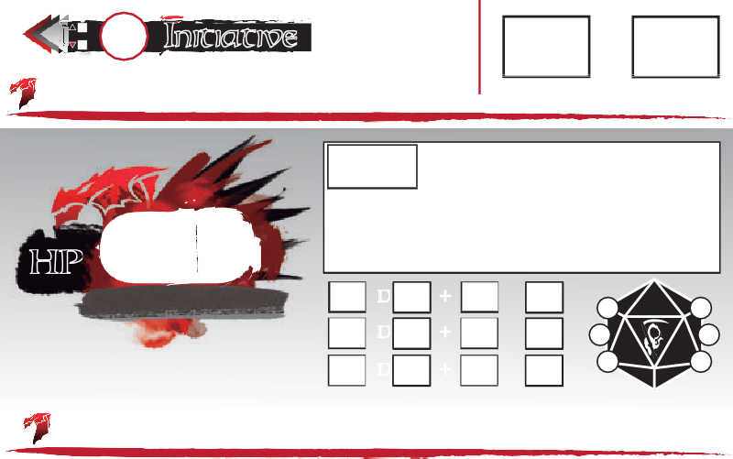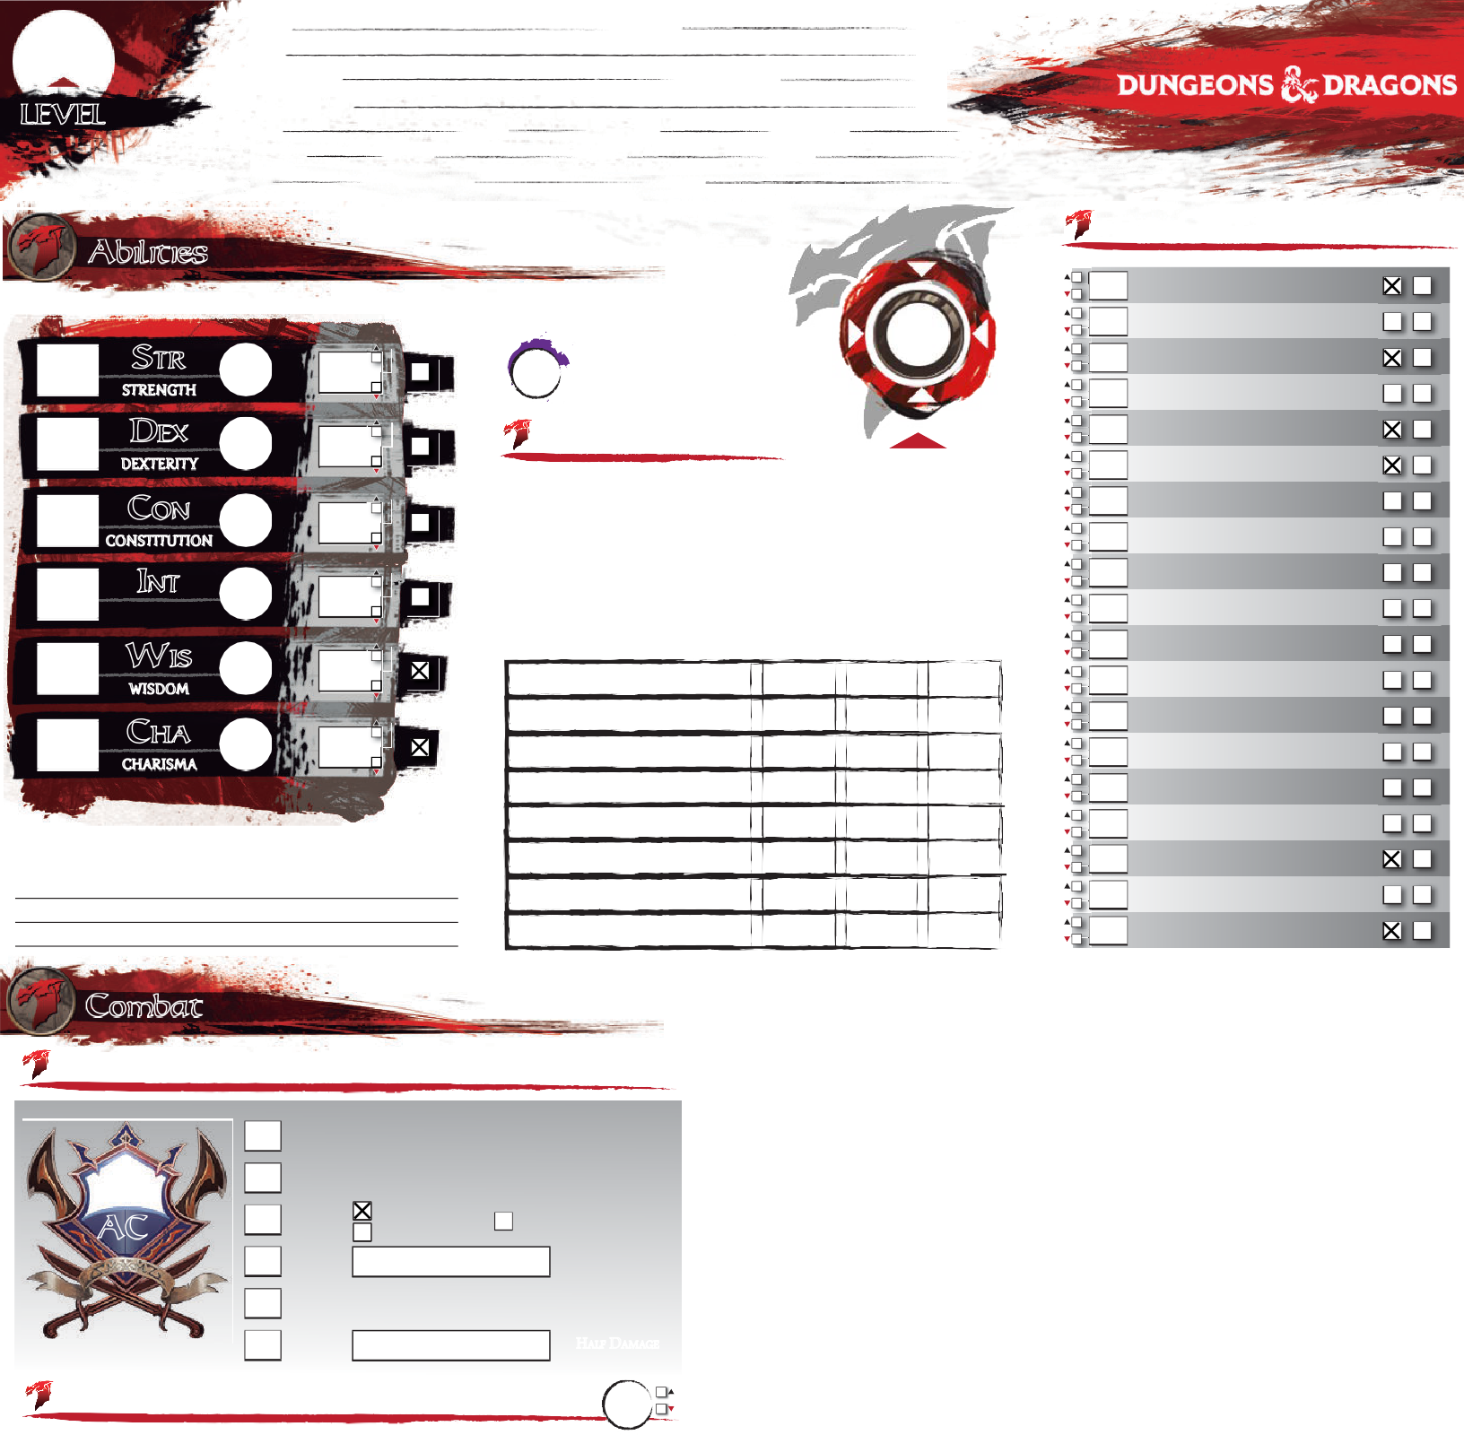
AMMUNITION

Features

Get the latest version of this sheet on enworld.org

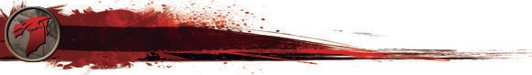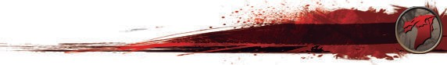 Check out the good stuff, Hired Killer
Background
PERSONALITY TRAITS

Human (+1 to two different ability scores of my choice)
Racial Traits
Skills:
I gain proficiency in one skill of my choice.

Feat:
I gain one feat of my choice.

Class Features
Armor: Light Medium Heavy Shi
Weapons: Si Ma tial Other:
Thorn's Training -"My Armor is a Second Skin" +1 to Dex add Maximum and no
L
Shields
Simple
Mar
O
disadvantage to stealth rolls while wearing chain

Warlock (Great Old One), level 7: 2 Spell Slots, 3rd Level power
- Pact Magic (Warlock 1, PHB 107)
I can cast warlock cantrips/spells that I know, using Charisma as my spellcasting ability
I can use an arcane focus as a spellcasting focus
I regain these spell slots on a short rest
- Awakened Mind (Great Old One 1, PHB 110)

I can communicate telepathically one-way to any seen creatures within 30 ft of me
- Eldritch Invocations (Warlock 2, PHB 107) [4 invocations known]

I_{DEAL}
Aspiration: do what it takes to be wealthy

B_{OND}
with an actual Great Old one-pay off a debt by creating a new religion

F_{LAW}
Forget the plan!!!
FEAT:
Moderately Armored
Feats
Bonus feat from being a human; (PHB, page 168)
I gain proficiency with medium armor and shields.[+1 Strength or Dexterity]

FEAT:

Use the "Choose Features" button above to add Eldritch Invocations to the third page
- Pact of the Tome (Warlock 3, PHB 107)

I have a Book of Shadows with any three cantrips of my choosing
FEAT:
I can cast these cantrips as long as I have the book on my person
Regardless of the lists they come from, these count as warlock cantrips to me
I can get a replacement book with a 1-hour ceremony during a short or long rest
- Entropic Ward (Great Old One 6, PHB 110) [1× per short rest]
As a reaction, when I'm attacked, I can impose disadvantage to that attack roll
FEAT:
If it misses me, I have adv. on my next attack vs. the attacker during my next turn
Equipment

A G |  | W
Case w/20 bolts 2.5#
Burglar's Pack 93.5#
Herbalist's Kit w/poison 3#
Light Crossbow 5#
Scroll Case 1#
4 sheets Paper
Pouch 1#
Blanket 3#
Candles | 5
Pen | 2
Sack 1/2# | 2
Longbow 2#
Quiver w/20 Arrows 2#
Club 2#
Dice gaming set
Torch 1# | 6
Robes 4#
Travelers Clothes 4#

I have a reliable and trustworthy contact who acts as my liaison to a network of other
Background Feature
Criminal Contact
A G |  | W
Explorer's Pack |  | 12
Focus (Crystal) |  | 1
Healer's Kit (10) |  | 3
Tankard |  | 1
Thieves Picks and Tools |  | 1
Pouch |  | 1
Whistle |  | 0
Chalk | 2 | 0
Book of Shadows |  | 1
Shield |  | 6
Spear |  | 3
Dagger and Sheath |  | 1
Breastplate +1 |  | 20
Common Clothes |  | 3
 |  | 53

criminals. I know how to get messages to and from my contact, even over great distances;
specifically, I know the local messengers, corrupt caravan masters, and seedy sailors who
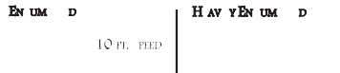 can deliver my messages. "Oxie"
66 -
HEA IL E E E
STR × 5
131 -
STR × 10
130 lb.-
195 lb.
-
20 FT. SPEED
DISADV. STR, DEX, CON
PLATINUM GOLD ELECTRUM SILV
= 10 GP =10SP = 5 SP =10

Keller Manzarek |  | 4
 |  | 4
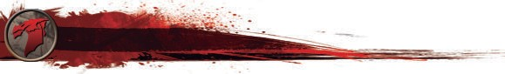H AG LI T TOTAL WEIGHT
Proficiencies
Languages
Tools & Others
A
I

196 -
57.6 lb.
STR × 15 - 30

390 lb.SPEED = 5 FT.
ER COPPER LIFESTYLE:
30 DAILY PRICE:
GEMS AND OTHER VALUABLES:
2-10 gpv

CP

GEAR & COINS

Common
Undercommon

Dice gaming set
Thieves' tools

©DESIGN BY JAVIER AUMENTE - JAAUVEL@GMAIL.COM; EDITS & FORM FIELDS BY JOOST WIJNEN - FLAPKAN@GMAIL.COM. THE D&D LOGO AND DRAGONS ARE ©WIZARDS OF THE COAST

CHARACTER: Pretor
Status
LEVEL EFFECT (CUMULATIVE)
- Disadvantage on Ability Checks
- Speed halved
- Disadvantage on Attack Rolls and Saving Throws
- Hit Point maximum halved
- Speed reduced to 0
- Death

Magic Items

MAGIC ITEM: Circlet of Disguise
ATTUNED
functions as a Hat of Disguise
Exhaustion
oss ssions
©DESIGN BY JAVIER AUMENTE - JAAUVEL@GMAIL.COM; EDITS & FORM FIELDS BY JOOST WIJNEN - FLAPKAN@GMAIL.COM. THE D&D LOGO AND DRAGONS ARE ©WIZARDS OF THE COAST

MAGIC ITEM: Keller Manzarek
✔ ATTUNED

Mace +1, acts as a Spell Focus, Heals up to 3x level in HP (Long Rest to recharge)
MAGIC ITEM: Breastplate +1
ATTUNED

taken from Father Donnegan in Everard Keep

Blinded
Conditions
FINISHING A LONG REST REDUCES THE EXHAUSTION LEVEL BY 1,
PROVIDED THAT YOU ALSO INGESTED
SOME FOOD AND DRINK.
Fail checks involving sight; attacks have disadvantage; enemy attacks have advantage.
Charmed
Cannot harm the charmer; charmer has advantage on any social interaction.
Deafened
Fail checks involving hearing.
Frightened
Check and attacks have disadvantage when source of fear is in sight; cannot willingly move closer to the source of fear.
Grappled
Speed drops to 0.
Incapacitated
Cannot take actions or reactions.
Invisible
Cannot be seen (normally); attacks have advantage; enemy attacks have disadvantage.
Paralyzed
Become incapacitated; fail Str and Dex saving throws; enemy attacks have advantage; enemy attacks within 5 ft are critical hits; cannot speak, move or take physical actions.
Petrified
Become incapacitated; become paralyzed; gain resistance to all damage; stop aging; immune to poison or disease; weight increase by a
MAGIC ITEM:
ATTUNED
factor of 10.
Poisoned
Ability checks have disadvantage; attacks have
disadvantage.
MAGIC ITEM:
ATTUNED
Prone
Only move by crawling or stand up; attacks
have disadvantage; enemy attacks have
advantage if within 5 ft or have disadvantage
otherwise.

Restrained
Speed drops to 0; attacks have disadvantage; enemy attacks have advantage; Dex saving
MAGIC ITEM:
ATTUNED
throws have disadvantage.
Stunned
Become incapacitated; fail Str and Dex saving
throws; enemy attacks have advantage; cannot move; can only speak falteringly.
MAGIC ITEM:
ATTUNED
Unconscious
Become incapacitated; fall prone and drop
what is holding; fail Str and Dex saving
throws; enemy attacks have advantage; enemy
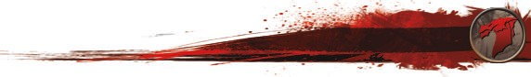attacks within 5 ft are a critical hits.
CNotebsat Rules
- DDaesvhil's Sight (EldritchAInctvioocnation,YoPuHgBai1n1y0o)ur Speed as extra movement this turn.
DiIsceanngsaeegein magical aAncdtionnonmagYiocuarl dmaorvkenmesesntoudtoetson1’t2p0rofvtoke Opportunity Attacks for the
- Book of Ancient Secrets (EldritchreIsntvoofcathteiotnu,rnP.HB 110)
DoIdcagneadd any two 1sAtc-tlieovnel spelDlsistahdavtanhtaavgee tohneArtittaucaklRtaogllstaogmainysBt yoooku. oYfoSuhhaadvoewAsdvantage
If I come across spells with the rSitTuRal(Atathgl,etIiccsa)notrraDnEsXcr(iAbcertohbeamticsin) tcohemckyvbso. ookp,paosnewnetl’ls STR
E
on DEX Saving Throws.
sIccaapnecaGstraapnyploef thesAecstipoenlls in m(AythBleotoicks)ofchSehcakdtoowbse farseeriotuf athlse,gbruatppnloetd acsonndoirtimona.l spells
- Eyes of the Rune Keeper (EldritchRoIlnl vitocmaatkioens ,vsP.HanBo1p1po1n)ent within 5 ft of you.
HeIlcpan cast my knownAwctaiorlnock spYeollus agsivreitaunaalsllyifAtdhveaynhtaagveeotnhethreitnueaxlttAabgility Check or Attack
HiIdcean read all writingAction
DEX (Stealth) check vs. opponent’s WIS (Perception) check.
I can add my Charisma modifier
- OAvgeornrizuinng Blast (EldrAictctihonInovrocatWionin,oPpHpoBsi1n1g0ST)R (Athletics) check to move through opponent’s
Bonus Acti
on
space once this turn. Advantage if you are larger than opponent
antdo dtihseaddvaamntaaggee ioffymouyaEreldsrmitaclhlerBtlahatn coapnptornipent.
s
Ready Search Tumble
Action

Action
You choose an action you will take in response to a trigger, using your Reaction. Readying a spell requires concentration.
You search for something.
Action or Win opposing DEX (Acrobatics) check to move through B n c e
You can interact with an object once per turn for free.
Weapon attack roll vs. opponent’s STR (Athletics) or DEX (Acrobatics) check to knock one item from its grasp. You have
Disarm Attack disadvantage if opponent is holding item with two or more
hands. Opponents larger than you have advantage. Opponents
smaller than you have disadvantage.
Win STR (Athletics) check vs. opponent’s STR (Athletics) or DEX
Grapple Attack (Acrobatics) check. Can only start grapple with opponents that
are up to one size larger than yourself.
Together with a melee attack you can mark the target of that Melee attack. Until the end of your next turn, make one opportunity
Use Object
onus Actio opponent’s spa e onc this turn.
You interact with an object.
Action
Mark
Attack attack against the marked target with advantage without
expanding your reaction.
Win opposing STR (Athletics) check to move opponent 5 ft back.
Shove
Attack
Disadvantage if trying to move the opponent to a side.
Bring grappled opponent along with you as part of your move
Move Grappled Move action, but can only move half speed unless opponent is two or more sizes smaller than you.

Combat Rules

G
W G W
EDxpalsohrer's Pack ConteAncttsion You gain youBr uSpregeladra'ss ePxatrcakmCoovenmteennttsthis turn.

Backpack
1D0i'sSetnrginagge Action
Your mo5vemBenatckdpoeascnk’t provoke Opportunity Attacks for5the rest of the tuBrna.g of 1000 Ball Bearings 2

MDeossdgKeit Tinderbox
Action
Disadvan1tage on Attack Rolls against you. You have Advantage on DEX Saving Throws.
STR (Ath1letics) or DEX (Acrobatics) check vs. opponent’s STR
Bell

TEosrccahpese Grapple Action
(A3thletic1s) chCeacnk dtolebse free of the grappled condition5.

FHlaesklpOil
Action
Yo2u give1an aCllryoAwdbvaanrtage on the next Ability Check or Att5ack

Roll it makesHvsa.manmoeprponent within 5 ft of you. 3

Hide Action
Action or
DEX (StealthP) icthoencksvs. opponent’s WIS (Perception)10che0c.k2.5
Win opposingHSoToRd(eAdthLleatincst)ecrhneck to move through oppone2nt’s

Overrun
Bonus Action
space once this turn. Advantage if you are larger than opponent

and disadvanOtabgseidifiaynouCahreusnmkasller than opponent. 2

Ready Action
You choose aDn aaciltyionRyaotuiownisll take in response to a tri1g5ger, us2ing

your ReactioTn.inRdeaedrybionxg a spell requires concentration. 1

Search Action
Tumble Action or
You search foWr asotmerestkhiinng.(full) 2 8
Win opposin5g0'DREoXpe(A(chreombapti)cs) check to move2 thr1o0ugh

Bonus Action
Bedroll
Use Object Action

Disarm Attack
opponent’s space once this turn.
You interact with an object. 7
You can interact with an object once per turn for free.
Weapon attack roll vs. opponent’s STR (Athletics) or DEX (Acrobatics) check to knock one item from its grasp. You have disadvantage if opponent is holding item with two or more hands. Opponents larger than you have advantage. Opponents smaller than you have disadvantage.

TOTAL WEIWGHinT STR12(Athletics) check vs. opponent’s STTORTA(LAWthEleIGtHicTs) 9o5r .D5EX

Grapple Attack
(Acrobatics) check. Can only start grapple with opponents that are up to one size larger than yourself.

Other HoldingTosgether with a melee attack you can mark the target of that

Melee Attack
Mark
attack. Until the end of your next turn, make one opportunity attack against the marked target with advantage without

expanding your reaction.

Shove Attack
Win opposing STR (Athletics) check to move opponent 5 ft back. Disadvantage if trying to move the opponent to a side.
Bring grappled opponent along with you as part of your move

Move Grappled Move action, but can only move half speed unless opponent is two or
©DESIGN BY JAVIER AUMENTE - JAAUVEL@GMAIL.COM; EDITS & FORM FIELDS BYmJOoOrSTeWsiIJzNeENs- sFLmAPKaAlNl@eGrMtAhILa.CnOMy. ToHuE .D&D LOGO AND DRAGONS ARE ©WIZARDS OF THE COAST

Character History
Appearance

Character Portrait

Organization Symbol
Enemies
Background
Pretor was born to be a Warlock, but he got his start as criminal. Somewhat strong and quick as well as clever, he was used as a torpedo by the local gang of hoods, until they realized how effective he was. Imagine a menacing street prophet, if you will. He has black hair and sallow skin, with piercing hazel eyes. When not on a job, he wears a robe. As to his origin, he was a foundling, raised by a crazy old laudanum addict, who is apparently dead (he did not kill her). After her demise, circumstances turned him to the two-bit local gang and its lifestyle. His philosophy can be found in a number of poems [cf. Rob Zombie lyrics]. He will share this with people if they stay around long enough to listen. His revelations have been best served recently by devotion to Karamaka. This proved to be dangerous when Sir Gavin and his bunch of Avenar amateurs made their sweep of the village.

He still has a criminal contact as per Criminal character generation. This person is named Oxie. Oxie is the only person who does not deal with Pretor with trepidation or fear. This person is very ambitious and may not still be in the original village [but I am leaving this to the DM].

Spells: Cantrips: Eldritch Blast Mage Hand Thorn Whip (Book) Thaumaturgy (Book) Shocking Grasp (Book) Chill Touch

1st: Hex Arms of Hadar Dissonant Whispers

2nd: Detect Thoughts

3rd: Magic Circle Fly

4th: Banishment Dimension Door

Rituals (Book of Ancient Secrets gives ability to cast no matter what class) Find Familiar w1 Tenser's Floating Disk w1
Allies & Organizations

Nessian Chord

Name: Ji'aa
Familiar
Race: Raven

Gender: Female

Age: 4

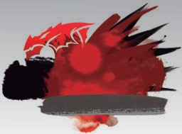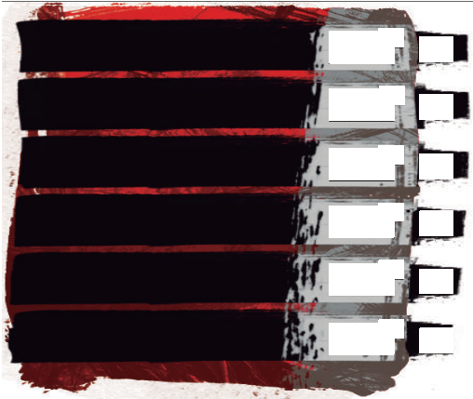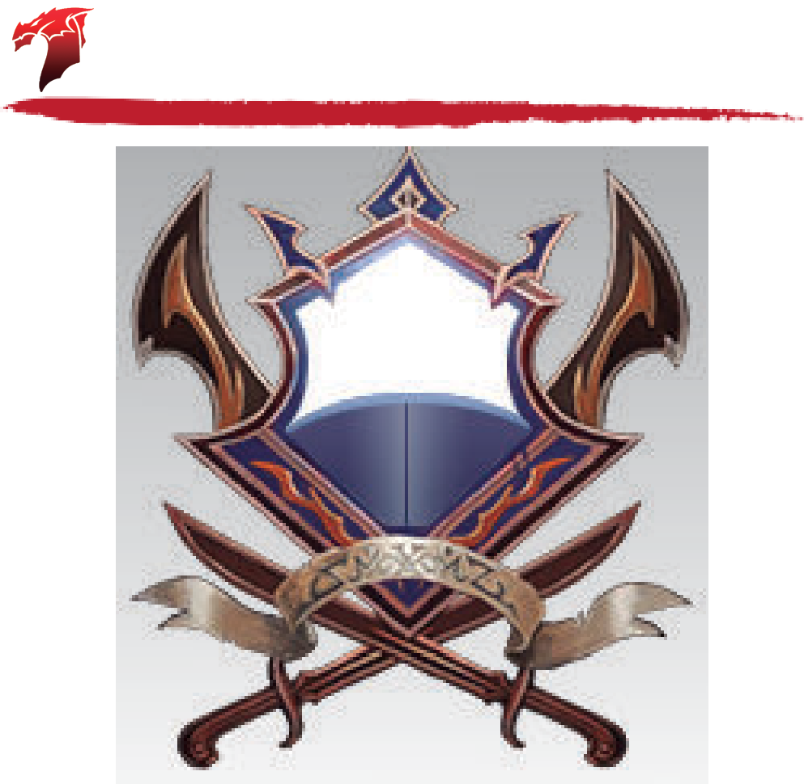Height: 8"
ABILITY
MODIFIER
2
8
S_{TR}
STRENGTH

D_{EX}
DEXTERITY

C_{ON}
CONSTITUTION

I_{NT}
INTELLIGENCE

W_{IS}
WISDOM
-4
SAVING THROW
BONUS
-4
Skills
Passive Perception
SENSES / SKILL PROFICIENCIES
Attacks
ATTACK / DESCRIPTION
Beak Attack
ATTACKS PER ACTION
RANGE
touch
TO HIT
+4
DAMAGE
1
DAMAGE TYPE
Piercing
14
+2
+2
-1
-1
Speed
2
-4
-4
Health
12
+1
+1
Defense
6
C_{HA}
CHARISMA
-2
-2
MISC.
DEX
+
Initiative
+2
Features
Annotations
USED
D +
LEVEL DIE CON
HIT DICE
MAX HIT POINTS
HP
III
TEMP.
3
II
12
AC
I DC10
2
WOUNDS
Heal
10 walk, 50 fly
11
Weight: 2#
Size: Tiny

Can deliver touch spells
Notes

©DESIGN BY JAVIER AUMENTE - JAAUVEL@GMAIL.COM; EDITS & FORM FIELDS BY JOOST WIJNEN - FLAPKAN@GMAIL.COM. THE D&D LOGO AND DRAGONS ARE ©WIZARDS OF THE COAST

Notes

