Name: Pretor
4
Class: Warlock (Great Old One)
Player: Jack Hollingsworth

Experience: 2.700
Next level: 6.500

LEVEL
Background: Criminal
Race: Human (Variant) Size:
Medium Height: 5' 11" Weight: 180

Gender: M Hair: Dark
Eyes: Hazel
Skin: Sallow

Abilities
Age: 25
Alignment: Neutral Evil
Faith: Heretic [Caramaka]

Skills
ADV
DIS BONUS NAME (ABILITY) PROF. EXP.

ABILITY MODIFIER SAVING THROW

PROF. BONUS

Ability save DC +2
Acrobatics (DEX)
Animal Handling (WIS)
+5
+1
= 8 + +
13

13 STR
STRENGTH
+1 +1
PROFIENCY BONUS

Charisma
+4 Arcana (INT)
+1 Athletics (STR)

16 DEX
DEXTERITY

CON

+3 +3
Senses
Passive Perception
11

Proficiency Bonus
+5 Deception (CHA)
+4 History (INT)
Insight (WIS)
+1

12
CONSTITUTION

14 INT
INTELLIGENCE

12 WIS
WISDOM

16 CHA
CHARISMA

+1 +1

+2 +2

+1 +3

+3 +5
Devil's Sight 120 ft
INSPIRATION

Limited Features
FEATURE MAX. USAGES RECOVERY USAGES
Intimidation (CHA)
+2 Investigation (INT) Medicine (WIS) Nature (INT) Perception (WIS) Performance (CHA) Persuasion (CHA) Religion (INT)
+3
+1
+2
+1
+3
+3
+2
+3
+5

Sleight of Hand (DEX)

Saving Throw Advantages / Disadvantages
Stealth (DEX)
Survival (WIS)
+1
Thieves' Tools (DEX)
+5

SPEED
30 ft

Combat Defense

ARMOR BONUS
14
+

AC DURING REST
+3

Health
DEX MISC.
Initiative +
3
SPEED
ENCUMBERED

20 ft

WOUNDS

19 2

SHIELD
Breastplate
14
Shield
BONUS
HALF DAMAGE

CURRENT
TEMPORARY HP

+
AC 2
+

+
1
DEXTERITY
MOD MAGIC
Thorn's Training
MEDIUM ARMOR (MAX = 2)
HEAVY ARMOR (MOD = 0)
STEALTH
DISADV.
RESISTANCE
HP 35
MAX HIT POINTS

4 D 8 + 1
I DC10

MISC MOD 1
D + II

Attacks
+
MISC MOD 2
ATTACKS PER ACTION
RECOVER HALF OF YOUR MAXIMUM
HIT DICE AFTER A LONG REST.

Actions
HIT DICE
D +
LEVEL DIE CON

USED
III

WEAPON / DESCRIPTION

PROF ABILITY

RANGE

TO HIT DAMAGE DAMAGE TYPE
1

MAXIMUM OF 1 ACTION, 1 BONUS ACTION, AND 1 REACTION PER TURN.

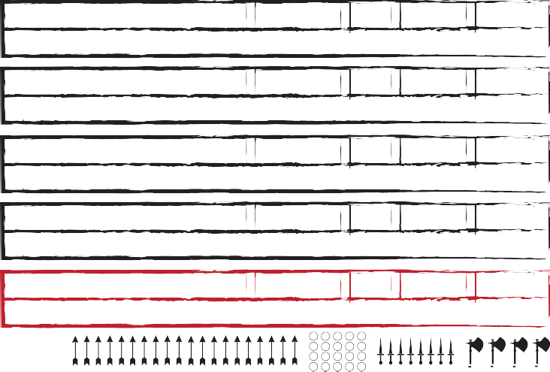
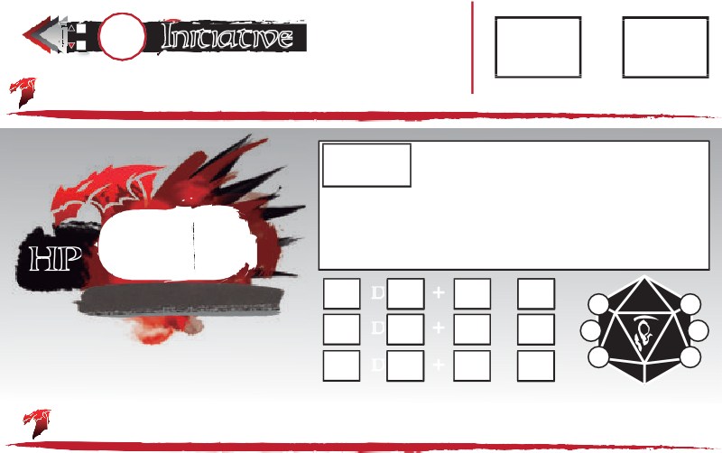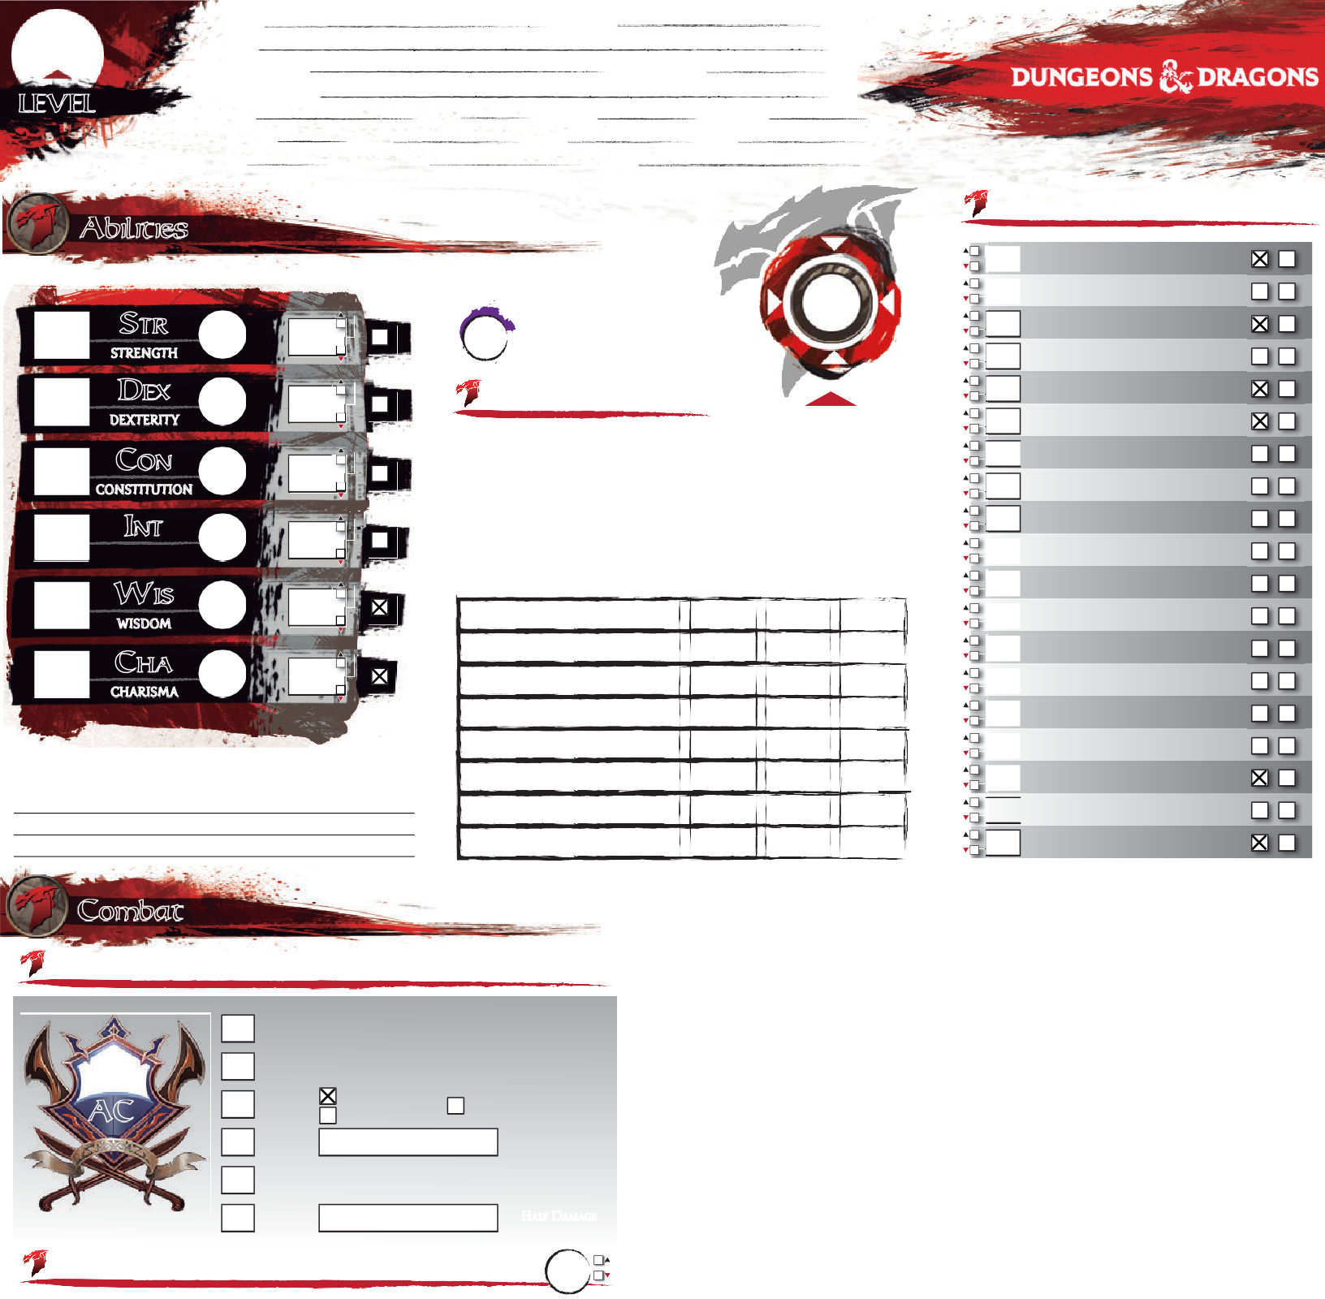Eldritch Blast ✔ Cha 120 ft. +5 1×1d10 Force

Each d10 is a separate beam requiring separate rolls (PHB 237)
Spear ✔
Str | Melee, 20/60 ft. | +3 | 1d6+1 | Piercing
Dex | 80/320 ft. | +5 | 1d8+3 | Piercing

Thrown, versatile (1d8)
Light crossbow ✔
Ammunition, loading, two-handed
Dagger ✔ Dex Melee, 20/60 ft. +5 1d4+3 Piercing

Finesse, light, thrown

AMMUNITION
Attack / Cast a Spell Dash / Disengage / Dodge
Escape Grapple / Help / Hide
Ready / Search / Use Object

Overrun / Tumble (or as bonus action)
As 1 attack: Disarm / Grapple / Shove
BONUS ACTIONS REACTIONS

Opportunity Attack

Features Racial Traits

Get the latest version of this sheet on enworld.org

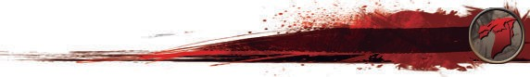 Check out the good stuff, Hired Killer
Background
PERSONALITY TRAITS

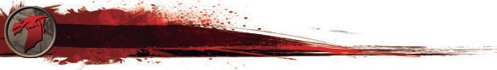 Human (+1 to two different ability scores of my choice)
Skills:
I gain proficiency in one skill of my choice.

Feat:
I gain one feat of my choice.
Class Features
Armor: Light MMedium Heavy Shi
Weapons: Si Ma tial Other:

Warlock (Great Old One), level 4:
L
Shields
Simple
Mar
O
- Pact Magic (Warlock 1, PHB 107)
I can cast warlock cantrips/spells that I know, using Charisma as my spellcasting ability
I can use an arcane focus as a spellcasting focus
I regain these spell slots on a short rest
- Awakened Mind (Great Old One 1, PHB 110)
I can communicate telepathically one-way to any seen creatures within 30 ft of me
- Eldritch Invocations (Warlock 2, PHB 107) [2 invocations known]
Use the "Choose Features" button above to add Eldritch Invocations to the third page
- Pact of the Tome (Warlock 3, PHB 107)

IDEAL
Aspiration: do what it takes to be wealthy

BOND
with an actual Great Old one-pay off a debt by creating a new religion

FLAW
Forget the plan!!!
FEAT:
Moderately Armored
Feats
Bonus feat from being a human; (PHB, page 168)
I gain proficiency with medium armor and shields.[+1 Strength or Dexterity]

I have a Book of Shadows with any three cantrips of my choosing
I can cast these cantrips as long as I have the book on my person/n Regardless of the
FEAT:
lists they come from, these count as warlock cantrips to me
I can get a replacement book with a 1-hour ceremony during a short or long rest
Equipment
FEAT:
FEAT:

Background Feature

Criminal Contact
I have a reliable and trustworthy contact who acts as my liaison to a network of other
criminals. I know how to get messages to and from my contact, even over great distances;
specifically, I know the local messengers, corrupt caravan masters, and seedy sailors who
can deliver my messages.

0
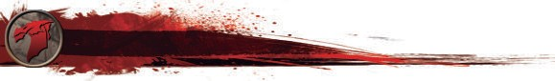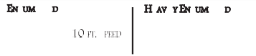H AG LI T TOTAL WEIGHT
Proficiencies
Languages
Tools & Others
66 -
HEA IL E E E
STR × 5
131 -
STR × 10
130 lb.-
195 lb.
-
20 FT. SPEED
DISADV. STR, DEX, CON
PLATINUM GOLD ELECTRUM SILV
= 10 GP =10SP = 5 SP =10
A
I
A G |  | W
Explorer's Pack
Focus (Crystal)
Healer's Kit (10)
Tankard
 |  | 0

A G |  | W
Case w/20 bolts
Burglar's Pack
Herbalist's Kit

196 -
STR × 15 - 30

390 lb.SPEED = 5 FT.
ER COPPER LIFESTYLE:
DAILY PRICE:
GEMS AND OTHER VALUABLES:
CP
0 lb.
GEAR & COINS

Common
Undercommon
Dice gaming set
Thieves' tools

©DESIGN BY JAVIER AUMENTE - JAAUVEL@GMAIL.COM; EDITS & FORM FIELDS BY JOOST WIJNEN - FLAPKAN@GMAIL.COM. THE D&D LOGO AND DRAGONS ARE ©WIZARDS OF THE COAST

CHARACTER: Pretor
MAGIC ITEM:
ATTUNED

oss ssions
Status

Exhaustion
Magic Items

Circlet of Disguise
MAGIC ITEM:
ATTUNED

MAGIC ITEM:
ATTUNED
FINISHING A LONG REST REDUCES THE EXHAUSTION LEVEL BY 1,
PROVIDED THAT YOU ALSO INGESTED
SOME FOOD AND DRINK.

Blinded
Conditions
LEVEL EFFECT (CUMULATIVE)
- Disadvantage on Ability Checks
- Speed halved
- Disadvantage on Attack Rolls and Saving Throws
- Hit Point maximum halved
- Speed reduced to 0
- Death
Fail checks involving sight; attacks have disadvantage; enemy attacks have advantage.

Charmed
Cannot harm the charmer; charmer has advantage on any social interaction.

Deafened
Fail checks involving hearing.

Frightened
Check and attacks have disadvantage when source of fear is in sight; cannot willingly move closer to the source of fear.

Grappled
Petrified
Become incapacitated; become paralyzed; gain resistance to all damage; stop aging; immune to poison or disease; weight increase by a
MAGIC ITEM:
ATTUNED
©DESIGN BY JAVIER AUMENTE - JAAUVEL@GMAIL.COM; EDITS & FORM FIELDS BY JOOST WIJNEN - FLAPKAN@GMAIL.COM. THE D&D LOGO AND DRAGONS ARE ©WIZARDS OF THE COAST
factor of 10.

Poisoned
Ability checks have disadvantage; attacks have
disadvantage.
MAGIC ITEM:
ATTUNED

Prone
Only move by crawling or stand up; attacks
have disadvantage; enemy attacks have
advantage if within 5 ft or have disadvantage
otherwise.

Restrained

Speed drops to 0.
Speed drops to 0; attacks have disadvantage; enemy attacks have advantage; Dex saving
MAGIC ITEM: ATTUNED

Incapacitated
Cannot take actions or reactions.

Invisible
Cannot be seen (normally); attacks have advantage; enemy attacks have disadvantage.

Paralyzed
Become incapacitated; fail Str and Dex saving throws; enemy attacks have advantage; enemy attacks within 5 ft are critical hits; cannot speak, move or take physical actions.
throws have disadvantage.

Stunned
Become incapacitated; fail Str and Dex saving
throws; enemy attacks have advantage; cannot move; can only speak falteringly.
MAGIC ITEM:
ATTUNED

Unconscious
Become incapacitated; fall prone and drop
what is holding; fail Str and Dex saving
throws; enemy attacks have advantage; enemy
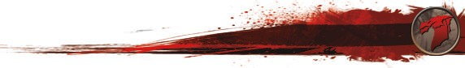attacks within 5 ft are a critical hits.
CNoomtebsat Rules
◆DRaesphelling Blast (EldritAchctiIonnvocatioYnou, PgaHiBn y1o1u1r )Speed as extra movement this turn.
- Devil's Sight (Eldritch Invocation,rePsHt oBf 1th1e0t)urn.
DiIsceannghaagvee creatures hAicttiboyn my EYlodurritcmhoBvelamsetnctadnotreispn’tbeprpouvsohkeedO1p0poftrtauwniatyyAfrtotamckms feor the
DoIdcagnesee in magical aAncdtionnonmagDiicsaalddvaanrktangeessonouAttttaock12Ro0llfstagainst you. You have Advantage
dEissacdavpaentGagreatpopslteealthArcotlilosnwhile(wAethalreitnigcs)chcahienck to be free of the grappled condition.
You give an ally Advantage on the next Ability Check or Attack
Thorn's Training -"My Armor is aSSTeRco(nAdthSlektiinc"s)+o1r tDoEDXe(xAacrdodbaMtiacxsi)mcuhmeckavnsd. onpoponent’s STR
on DEX Saving Throws.
Help
Hide
Action
Roll it makes vs. an opponent within 5 ft of you.
Overrun
Action or
Action DEX (Stealth) check vs. opponent’s WIS (Perception) check.
Win opposing STR (Athletics) check to move through opponent’s
and disadvantage if you are smaller than opponent.
You choose an action you will take in response to a trigger, using
Bonus Action space once this turn. Advantage if you are larger than opponent
Ready
Search Tumble
Action

Action
your Reaction. Readying a spell requires concentration.
You search for something.
Action or Win opposing DEX (Acrobatics) check to move through B n c e
onus Actio opponent’s spa e onc this turn.
You interact with an object.
You can interact with an object once per turn for free.
Weapon attack roll vs. opponent’s STR (Athletics) or DEX (Acrobatics) check to knock one item from its grasp. You have
Disarm Attack disadvantage if opponent is holding item with two or more
hands. Opponents larger than you have advantage. Opponents
smaller than you have disadvantage.
Win STR (Athletics) check vs. opponent’s STR (Athletics) or DEX
Grapple Attack (Acrobatics) check. Can only start grapple with opponents that
are up to one size larger than yourself.
Together with a melee attack you can mark the target of that Melee attack. Until the end of your next turn, make one opportunity
Use Object
Action
Mark
Attack attack against the marked target with advantage without
expanding your reaction.
Win opposing STR (Athletics) check to move opponent 5 ft back.
Shove
Attack
Disadvantage if trying to move the opponent to a side.
Bring grappled opponent along with you as part of your move
Move Grappled Move action, but can only move half speed unless opponent is two or more sizes smaller than you.

Combat Rules

G
W G W
Dash Action You gain your Speed as extra movement this turn.
Your
acks

Disengage Action
Dodge Action
movement doesn’t provoke Opportunity Att r of the turn.
Disadvantage on Attack Rolls against you. You hav on DEX Saving Throws.
est
STR (Athletics) or DEX (Acrobatics) check vs. opp
Athl
for the
vantage nt’s STR
e Ad
one
on.
ck o

Escape Grapple Action
( etics) check to be free of the grappled conditi

Help Action
Hide Action
You give an ally Advantage on the next Ability Che it makes vs. an opponent within 5 ft of you.
(Stealth) check vs. opponent’s WIS (Perceptio
Roll
DEX
r Attack

eck.
n) ch

Overrun
Action or Bonus Action
Win opposing STR (Athletics) check to move through opponent’s space once this turn. Advantage if you are larger than opponent and disadvantage if you are smaller than opponent.

Ready Action
Search Action
You choose an action you will take in response to a trigger, using Reaction. Readying a spell requires concentra
You search for something.
your
tion.

Action or onus Actio
Tumble B n
Use Object Action
Win opposing DEX (Acrobatics) check to mo opponent’s space once this turn.
You interact with an object.
You can interact with an object once per turn for fr Weapon attack roll vs. opponent’s STR (Athleti
through

or DEX
ve
ee.
cs)

Disarm Attack
(Acrobatics) check to knock one item from its grasp. You have
disadvantage if opponent is holding item with two or more hands. Opponents larger than you have advantage. Opponents
mal

s ler than you have disadvantage.
TOTAL WEIWGHinT STR 0(Athletics) check vs. opponent’s STTORTA(LAWthEleIGtHicTs) or D0EX

Grapple Attack
(Acrobatics) check. Can only start grapple with opponents that are up to one size larger than yourself.

Other HMoellede ingTosgether with a melee attack you can mark the target of that

Mark

Attack
attack. Until the end of your next turn, make one opportunity attack against the marked target with advantage without

expanding your reaction.

Shove Attack
Win opposing STR (Athletics) check to move opponent 5 ft back. Disadvantage if trying to move the opponent to a side.
Bring grappled opponent along with you as part of your move

Move Grappled Move action, but can only move half speed unless opponent is two or
©DESIGN BY JAVIER AUMENTE - JAAUVEL@GMAIL.COM; EDITS & FORM FIELDS BYmJOoOrSTeWsiIJzNeENs- sFLmAPKaAlNl@eGrMtAhILa.CnOMy. ToHuE .D&D LOGO AND DRAGONS ARE ©WIZARDS OF THE COAST

Appearance

Organization Symbol
Enemies
Background

Character History
Accused of Heresy

Character Portrait
Allies & Organizations

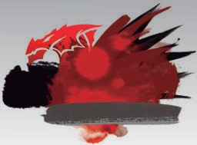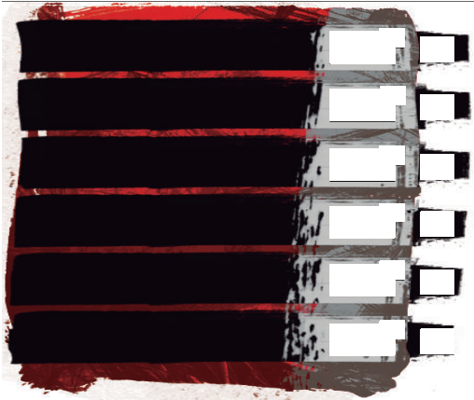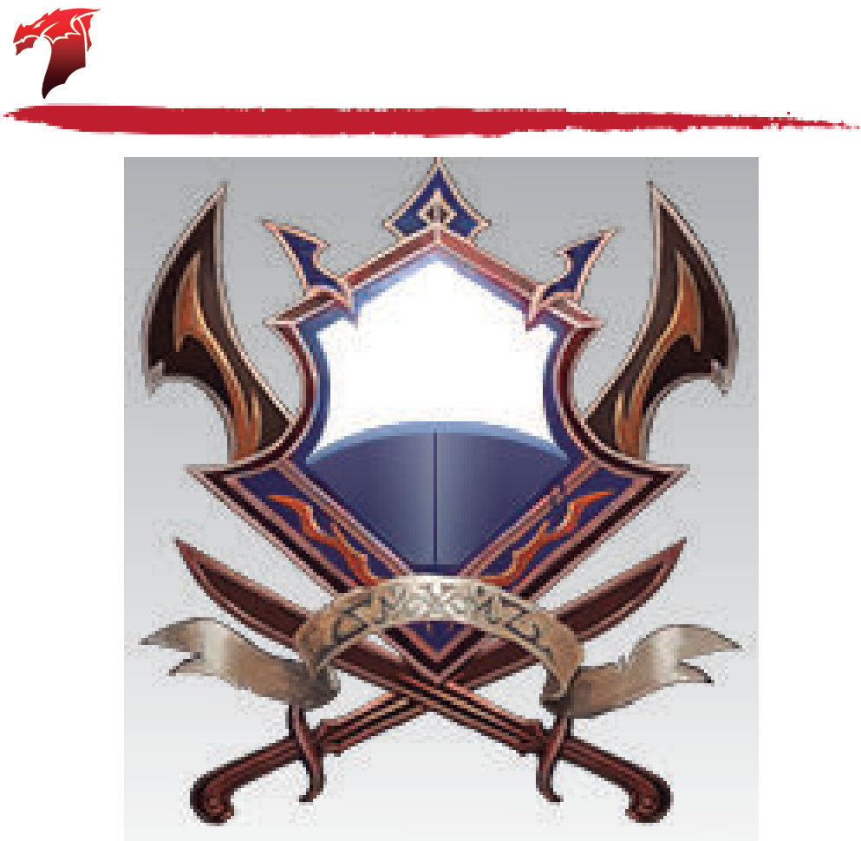Name: Race: Height:
ABILITY
MODIFIER
10
10
STR
STRENGTH

DEX
DEXTERITY

CON
CONSTITUTION

INT
INTELLIGENCE

WIS
WISDOM
0
SAVING THROW
BONUS
0
Skills
Passive Perception
SENSES / SKILL PROFICIENCIES

Attacks
ATTACK / DESCRIPTION
ATTACKS PER ACTION
RANGE
TO HIT
DAMAGE
DAMAGE TYPE
10
0
0
0
0

Speed
10
0
0
Health
10
0
0
Defense
I DC10
10
CHA
CHARISMA
0
0
II
TEMP.
III
AC
HP
MISC.
DEX
MAX HIT POINTS
HIT DICE
D
+
+
Initiative
0
LEVEL
DIE
CON
USED
Features
Annotations
Heal
WOUNDS
0
Companion

Gender: Weight:

Age:
Size:

Medium

Notes

Spells: Cantrips: Eldritch Blast Mage Hand Thorn Whip (Book) Thaumaturgy (Book) Shocking Grasp (Book) Chill Touch

1st: Hex Protection from Evil/Good Arms of Hadar Dissonant Whispers 2nd: Detect Thoughts

©DESIGN BY JAVIER AUMENTE - JAAUVEL@GMAIL.COM; EDITS & FORM FIELDS BY JOOST WIJNEN - FLAPKAN@GMAIL.COM. THE D&D LOGO AND DRAGONS ARE ©WIZARDS OF THE COAST

Notes

